ME 200 – Thermodynamics, L. Liebenberg

**Name:** Joseph Specht

**Quiz 8** (Total: 30 points)

**Due back on Wed. 5 April in the Quiz 8 folder on Canvas**

* *Follow the problem-solving strategy that you learnt in class. You will be penalized if you do not.*
* *Save your entire assignment as one PDF document and upload it in the appropriate assignment folder on Canvas.*
* *Assignments will only be graded if the honor code statement, below, is completed and signed.*

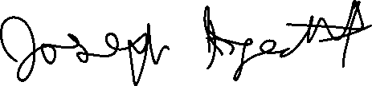

**Honor Code Statement**

***ME 200, Quiz 8***

Being a student of high standards, I pledge to embody the principles of *academic integrity*.

This ME 200 quiz is my own work. I did not seek (or get) outside help or collaboration with any of the questions and their solutions. I also did not offer my solutions to any other student.

I understand that this quiz is “open book” and “open notes” which means that I was permitted to use my prescribed textbook and lecture notes when addressing any of the questions. I have properly cited any other resources, with full cognizance of the regulations pertaining to plagiarism, copyright infringement, academic cheating, etc., as stipulated in the Student Code.

I acknowledge that academic violations will be dealt with according to the UIUC Student Code, Article 1, Part 4.

ME 200 Student’s signature: Student’s Name: Joseph Specht

Net-ID: jspecht3

Date: 4/2/23

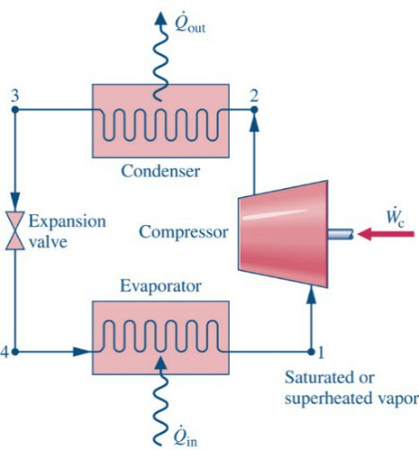Consider an air-conditioning system that operates on an ideal vapor- compression cycle. The system uses R-134a as refrigerant. The refrigerant enters the compressor as a saturated vapor at 5ºC and leaves the condenser as a saturated liquid at 55ºC. The mass flowrate of the refrigerant is 0.7 kg/s.

1. Draw the cycle on a *p*-*h* diagram and indicate all state points. Clearly show the processes where heat and work transfer take place. Also indicate all known temperatures and pressures. *(2)*



T_1 = 5 *C (sat vapor)

T_3 = 55 *C (sat liquid)

…………………………………………………………………………………………………………



…………………………………………………………………………………………

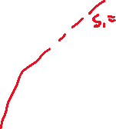

…………………………………………………………………………………………………………



…………………………………………………………………………………………………………

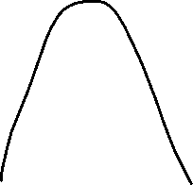

…………………………………………………………………………………………………………



…………………………………………………………………………………………………………



…………………………………………………………………………………………………………



1. Complete this table *after* you have performed all calculations in Questions 3 – 5. (No credit will be given for completing the table. Non-completion of the table will however result in 5 points being deducted from your quiz total.)

|  |  |  |  |
| --- | --- | --- | --- |
| **Process** | **Specific heat, *q***  **(kJ/kg)** | **Specific work, *w***  **(kJ/kg)** | **Change in specific enthalpy,**  ***h*exit – *h*inlet**  **(kJ/kg)** |
| **1 – 2** | 0 | -30.7455 | 29.8675 |
| **2 - 3** | -151.548 | 0 | -151.548 |
| **3 - 4** | 0 | 0 | 0 |
| **4 - 1** | 120.8025 | 0 | 120.8025 |
| **Σ:** | -30.7455 | -30.7455 | 0 |

# Calculate the specific enthalpies and specific entropies at state points 1, 2, 3 and 4. Show ALL interpolations! *(16)*

We know that @ state point 1, we have a saturated refrigerant 134a that is a saturated vapor, so go to table A-10 and interpolate to find the enthalpy and entropy

$\frac{h_{1}-h_{g@T=4°C}}{5°C-4°C}=\frac{h_{g@T=8°C}-h_{g@T=4°C}}{8°C-4°C}$

$$\frac{h_{1}-249.53}{5-4}=\frac{251.80-249.53}{8-4}$$

$$h_{1}=250.0975\frac{kJ}{kg}$$

Now we must repeat the same process to find the entropy!

$$\frac{s_{1}-s_{g@T=4°C}}{5°C-4°C}=\frac{s_{g@T=8°C}-s_{g@T=4°C}}{8°C-4°C}$$

$$\frac{s_{1}-.9169}{5-4}=\frac{.9150-.9169}{8-4}$$

$$s_{1}=.916425\frac{kJ}{kg*K}$$

Before we calculate the values at state point 2, we need to know the pressure at this state, but we are in luck as the pressure at state point 3 and 2 are the same and we know information about state point 3.

@ State point 3, we have a saturated liquid at T=55*C, so using table A-10, we can find all these values

$$\frac{p_{3}-p_{sat@55°C}}{55°C-52°C}=\frac{{p_{sat@56°C}-p}_{sat@55°C}}{56°C-52°C}$$

$$\frac{p_{3}-13.851}{55°C-52°C}=\frac{15.278-13.851}{56°C-52°C}$$

$$p_{3}=p_{2}=14.92125 bar$$

After solving state point 3, we can find the enthalpy and entropy at state point 2. We know that state points 1 and 2 have the same entropy and we know state point 2 will be superheated as you do work on a saturated vapor that experiences adiabatic compression. We also know the pressure is equal to p_3.

$$\frac{h_{3}-h_{f@p=14bar}}{14.92125bar-14bar}=\frac{h_{f@p=16bar}-h_{f@p=14bar}}{16bar-14bar}$$

$$\frac{h_{3}-125.26}{14.92125-14}=\frac{134.02-125.26}{16-14}$$

$$h_{3}=129.295\frac{kJ}{kg}$$

If we do the same interpolation process for the entropy, we get…

$$\frac{s_{3}-s_{f@p=14bar}}{14.92125bar-14bar}=\frac{s_{f@p=16bar}-s_{f@p=14bar}}{16-14}$$

$$\frac{s_{3}-.4453}{14.92125-14}=\frac{.4714-.4453}{16-14}$$

$$s_{3}=.4573\frac{kJ}{kg*K}$$

Now that we have solved for state point 3, we can realize s_1 = s_2 and use table A-12 to solve for h_2.

$$\frac{h_{2}-h_{@p=14,T=60}}{14.92125bar-14bar}=\frac{h_{@p=16,T=60}-h_{@p=14,T=60}}{16bar-14bar}$$

$$\frac{h_{2}-283.10}{14.92125-14}=\frac{278.20-283.10}{16-14}$$

$$h_{2}=280.843\frac{kJ}{kg*K}$$

Since we know h_3 = h_4, the only information we need to find is s_4, so we go to table A-10 as state point 4 lies in the saturated mixture region. We know p_1 = p_4, so we must find p_1 first.

$$\frac{p_{1}-p_{sat@T=4}}{5°C-4°C}=\frac{p_{sat@T=8}-p_{sat@T=4}}{8°C-4°C}$$

$$\frac{p_{1}-3.3765}{5-4}=\frac{3.8756-3.3765}{8-4}$$

$$p_{1}=p_{4}=3.5013 bar$$

Now that have these two properties, we can find the value of s_4 from table A-10. But first, we must find the vapor quality.

$$h_{4}=h_{f@p4}+x*h_{fg@p4}$$

$$\frac{h_{f@p4}-55.35}{3.5013-3.3765}=\frac{60.73-55.35}{3.8756-3.3765}$$

$h_{f@p4}=$ 56.70

$$\frac{h_{fg@p4}-194.19}{3.5013-3.3765}=\frac{191.07-194.19}{3.8756-3.3765}$$

$$h_{fg@p4}=193.401$$

Since we know h_4, h_f@p4, and h_fg@p4, we can find x

$$x=\frac{h_{4}-h_{f@p4}}{h_{fg@p4}}=.3754$$

If we have this value, we can then interpolate from A-10 to find s_4

$$s_{4}=s_{4f}+x*s_{4fg}$$

First, we need to find the values of s_f and s_fg, so

$$\frac{s_{4f}-.2162}{3.5013-3.3765}=\frac{.2354-.2162}{3.8756-3.3765}$$

$$s_{4f}=.221$$

Now, we have to find s_g to find s_fg

$$\frac{s_{4g}-.9169}{3.5013-3.3765}=\frac{.9150-.9169}{3.8756-3.3765}$$

$$s_{4g}=.916425$$

This means s_fg is…

$$s_{fg}=s_{g}-s_{f}=.6954$$

With all the entropies we need, we can find the final value of s_4

|  |  |  |
| --- | --- | --- |
| State point | H [kJ/kg] | S [kJ/(kg*K)] |
| 1 | 250.0975 | .916425 |
| 2 | 280.843 | .916425 |
| 3 | 129.295 | .4573 |
| 4 | 129.295 | .482 |

$$s_{4}=s_{4f}+{x*s}_{4fg}=.482$$

Now that we have all these values, we just need to calculate the work and heat transfer with the first law

$$\left(q_{in}-q_{out}\right)-\left(w_{in}-w_{out}\right)=h_{2}-h_{1}$$

For 1-2, we know this is adiabatic and gives no work, so

$$w_{in}=h_{1}-h_{2}=30.7455$$

For 2-3, we know this is an isobaric process, so work is zero and this process ejects heat, so q_out = 0

$$q_{out}=h_{3}-h_{2}=-151.548$$

For process 3-4, we know it is a valve that does no work or add any heat, so everything is 0.

For process 4-1, we know this is an isobaric process, so work is 0 and this raises the enthalpy, so q_out=0

$$q_{in}=h_{1}-h_{4}=120.8025$$

# Calculate the specific work required at the compressor. *(3)*

For 1-2, we know this is adiabatic and gives no work, so

$$w_{in}=h_{1}-h_{2}=30.7455$$

1. Calculate heat transfer rate (in kW) in the condenser. *(3)*

For 2-3, we know this is an isobaric process, so work is zero and this process ejects heat, so q_out = 0

$$q_{out}=h_{3}-h_{2}=-151.548$$

# Calculate heat transfer rate (in kW) in the evaporator. *(3)*

For process 4-1, we know this is an isobaric process, so work is 0 and this raises the enthalpy, so q_out=0

$$q_{in}=h_{1}-h_{4}=120.$$

# Calculate the coefficient of performance of the cycle. *(3)*

$COP=\frac{q_{out}}{w_{in}}=4.929$, which seems high